John Rene Lorelli

Data Science Foundations

Week 5

M5 Exercise Data Frames Histograms

1. The entire R code used when finding the minimum weight of an adult cat in (1).

> c<-read.csv("AnimalData.csv")

> ca<-data.frame(c)

> cats<-subset(ca, ca$Animal.Type == "Cat" & ca$Age.Intake >1)

> min(cats$Weight)

1. The answer obtained in (1).

5

1. The entire R code used when finding the maximum weight of an adult cat in (2).

> max(cats$Weight)

1. The answer obtained in (2).

[1] 13.5

1. The entire R code used when finding the mean(average) weight of an adult cat in (3).

> ca<-data.frame(c)

> cats<-subset(ca, ca$Animal.Type == "Cat" & ca$Age.Intake >1)

> mean(cats$Weight)

1. The answer obtained in (3).

[1] 8.806122

1. The entire R code used when finding the standard deviation of weights of adult cats in (4).

> ca<-data.frame(c)

> cats<-subset(ca, ca$Animal.Type == "Cat" & ca$Age.Intake >1)

> sd(cats$Weight)

1. The answer obtained in (4).

[1] 1.857884

1. The entire R code used when creating the histogram of adult cat weights in (5).

hist(cats$Weight, main = "Cats Weight", ylim=c(1, 131))

1. Screenshot of the histogram created in (5).
   1. 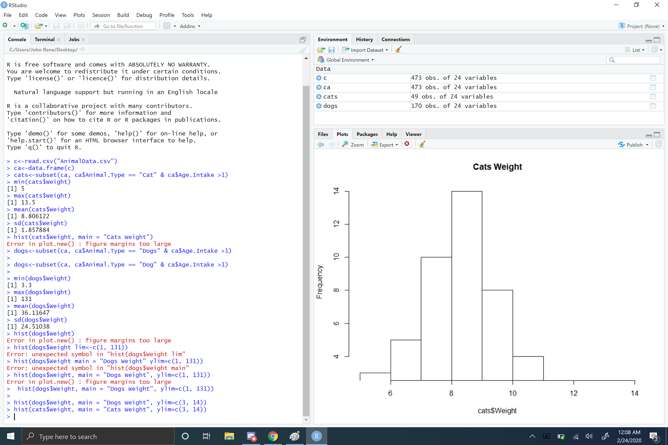
2. The entire R code used when finding the minimum weight of an adult dog in (6).

> dogs<-subset(ca, ca$Animal.Type == "Dog" & ca$Age.Intake >1)

> min(dogs$Weight)

1. The answer obtained in (6).

[1] 3.3

1. The entire R code used when finding the maximum weight of an adult dog in (7).

> max(dogs$Weight)

1. The answer obtained in (7).

[1] 131

1. The entire R code used when finding the mean(average) weight of an adult dog in (8).

> mean(dogs$Weight)

1. The answer obtained in (8).

[1] 36.11647

1. The entire R code used when finding the standard deviation of weights of adult dogs in (9).

sd(dogs$Weight)

1. The answer obtained in (9).

[1] 24.51038

1. The entire R code used when creating the histogram of adult dog weights in (10).

hist(dogs$Weight, main = "Dogs Weight", ylim=c(1, 131))

1. Screenshot of the histogram created in (10).

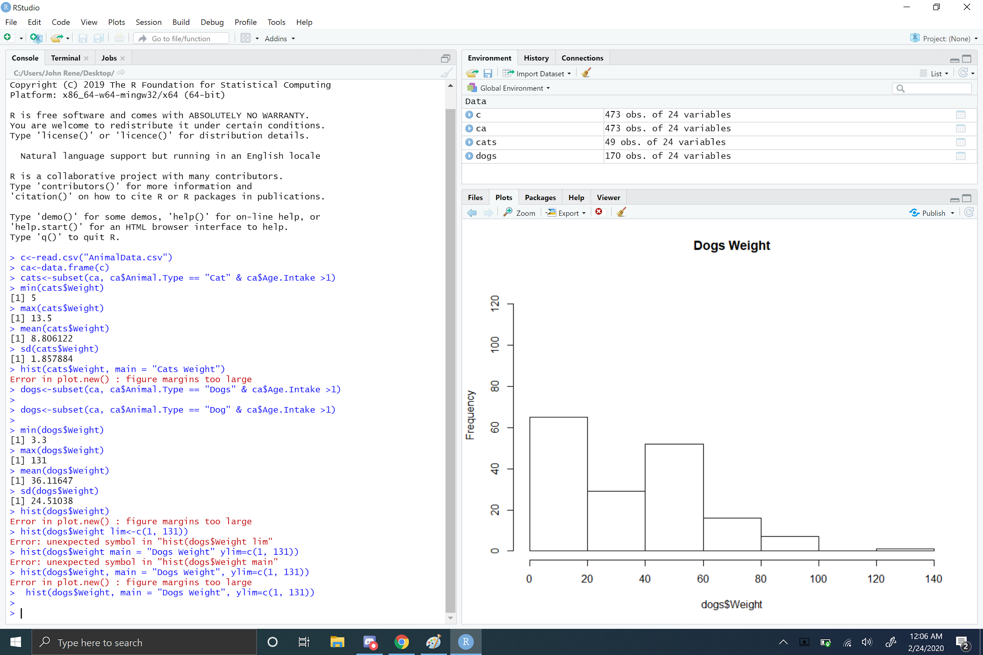

1. Whether the distribution of car weights and dog weights are more normal or skewed.

Dog is positive skewed and cats more even